**Case Study – User manual**

**“Only Flights”**

Project Members & Student Numbers:

* Kaloyan Andreev (4408020)
* Francisco Marcó (4467752)
* Sava Vasilev (4663438)

Elaboration Date: 3/11/2022

Case Study - Group 10

**Table of content**

1. Terraform Executor 2

a. What is the purpose of using Terraform Executor 2

b. How to interact properly with the application 2

c. Requirement before start using the Terraform Executor 4

d. Troubles while using the app ? 4

2. ‘OnlyFlights’ website 5

a. What is the purpose of using ‘OnlyFlights’ website 5

b. How to interact properly with the website feature 5

c. Requirement before start using the website 7

d. Troubles while using the app ? 7

# Terraform Executor

## What is the purpose of using Terraform Executor

The Terraform Executor is made for easily running and managing automation scripts. The user is able to create, modify or destroy cloud infrastructure by one click of the mouse.

## How to interact properly with the application

***Note:*** *Before you run start, make sure that all pre-made terraform scripts are situated in one place* (folder).

Once the app is running, you have to choose the directory (folder) where the scripts take a place by clicking the button ‘Select folder’.

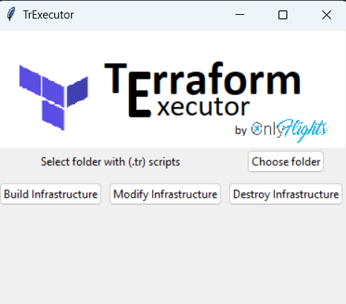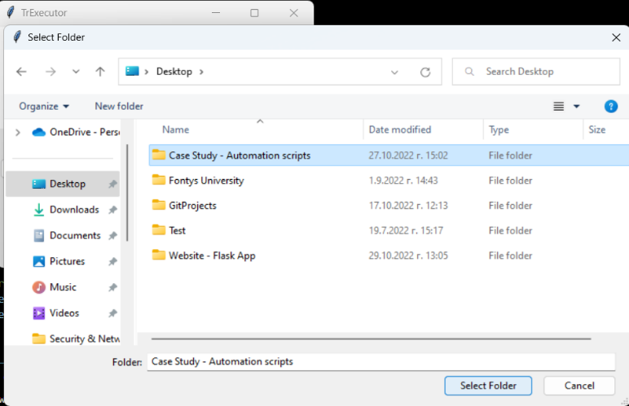

After successfully doing that, the path to the certain folder will be shown on the screen right below the ‘Select button’.

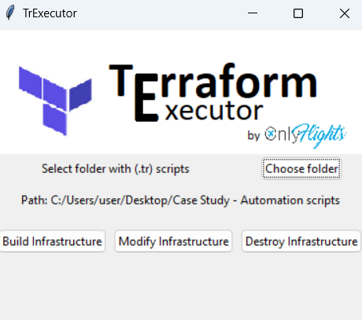

Then, it is time to execute the scripts. The user has three options. The first one is to build the cloud environment by clicking the button ‘Build infrastructure’. The program will perform the command ‘terraform apply’ and every service that is declared in the .tf files will be generated in AWS. This process might take some time depending on the number of components that will be created. Once everything is done, a successful message will appear on the screen for 7 seconds.

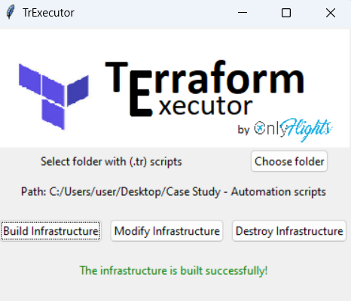

If the customer wants make changes to the infrastructure such as adding new service or changing configuration of already existing instance, the first thing to do is to edit the certain .tf files. Then, he or she can select the correct folder again and to perform the changes they have to click on the ‘Modify infrastructure’ button. The program will apply the new changes and after the end of process the user will be notified by a message show on the screen.

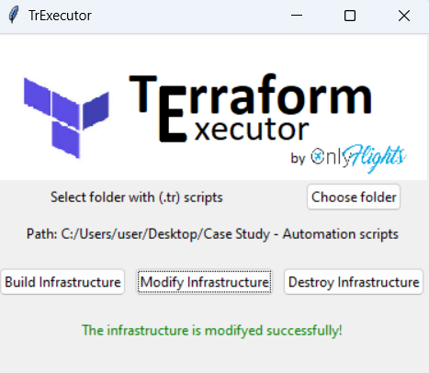

In case the client no longer needs their cloud environment, he or she can easily delete everything by clicking on the ‘Destroy Infrastructure’ button. As a preventive measure against accidentally pressing the button, a popup window asking for confirmation will be shown on the screen. If the user selects ‘Yes’, the application will run the command ‘terraform destroy’ and after successful deletion of the environment a message will appear on the screen. If the user clicks ‘No’, he or she will be return to the main window.

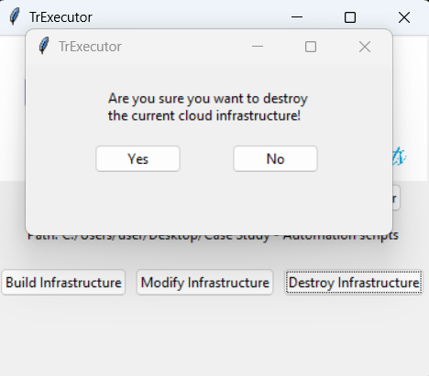

## Requirement before start using the Terraform Executor

* AWS CLI must be installed and configured on your local machine
* Make sure ‘Tkinter’ library is installed
* Mae sure ‘Python’ version is the latest
* Make sure the AWS account that will be used is authorized completely to use the services that will be constructed by the terraform scripts

## Troubles while using the app ?

In case of technical failure please report it immediately to one of the following developers so it could be solved as soon as possible

**Contact info:**

* [k.andreev@student.fontys.com](mailto:k.andreev@student.fontys.com)
* [sava.vasilev@student.fontys.com](mailto:sava.vasilev@student.fontys.com)
* [f.marco@student.fontys.nl](mailto:f.marco@student.fontys.nl)

# ‘OnlyFlights’ website

## What is the purpose of using ‘OnlyFlights’ website

Тhe purpose of using the ‚OnlyFlights’ website is to quickly find the plane ticket/s the clients want for their chosen destination. The customer can book flights and in case they are not able to use them, the tickets can be returned. The users must create an account before start interacting with the webapp.

## How to interact properly with the website feature

Once the webpage is open, the first thing to do (if you don’t have an account) is to make a profile. To do so, click on the “signup” button and fill the required information.

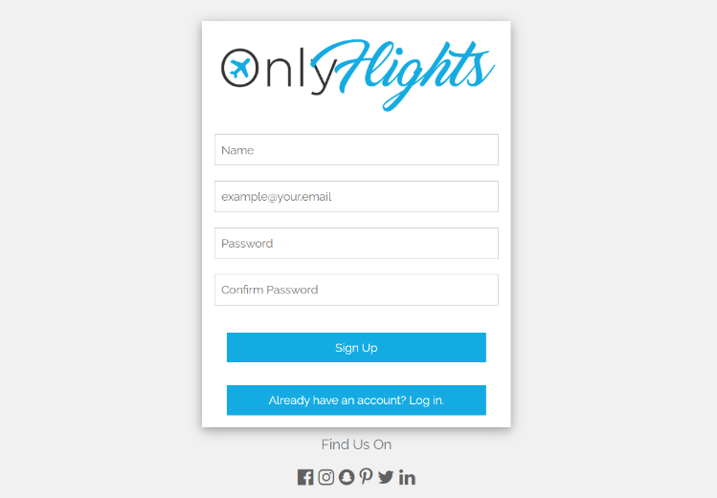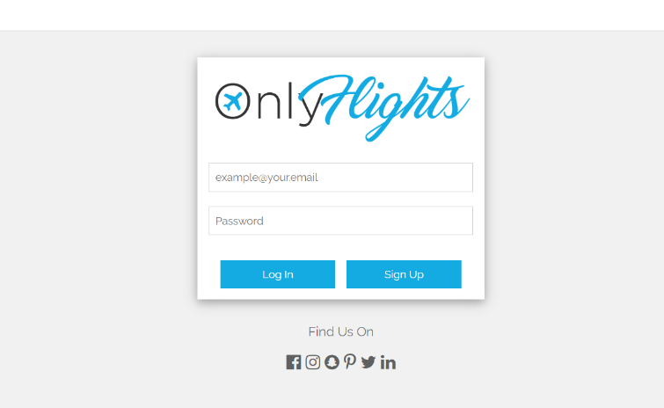

If you already have registration, enter your credentials and click login.

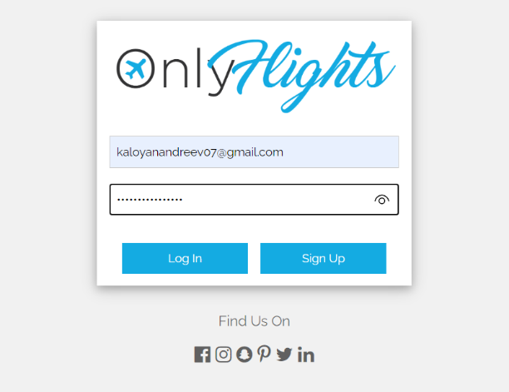

The home page contains is divided into several sections. On the center, the is a console from with the users can specify the departure date and airport and the arrival date and airport. Once the search button is clicked, the available flights will be shown under the Graphical user interface, text, application, email
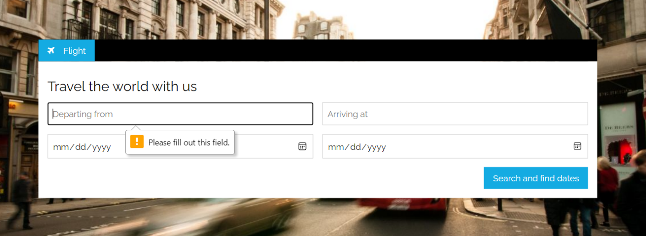console.

On the left-hand side, there is a menu with a few options: to redirect the user to his/her profile or home page and to log out of the account.

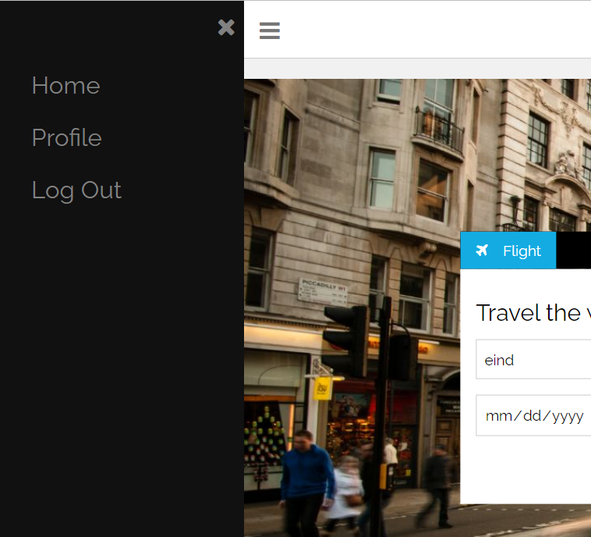

In the profile page, the user can take a look of the upcoming flights or previously booked tickets (1). On top left, there is general information about the user such as full name and username (2). Under them, there is a log out button (3) and in case the client feels insecure for their password, he or she can easily change it by entering the old and the new passwords (4).

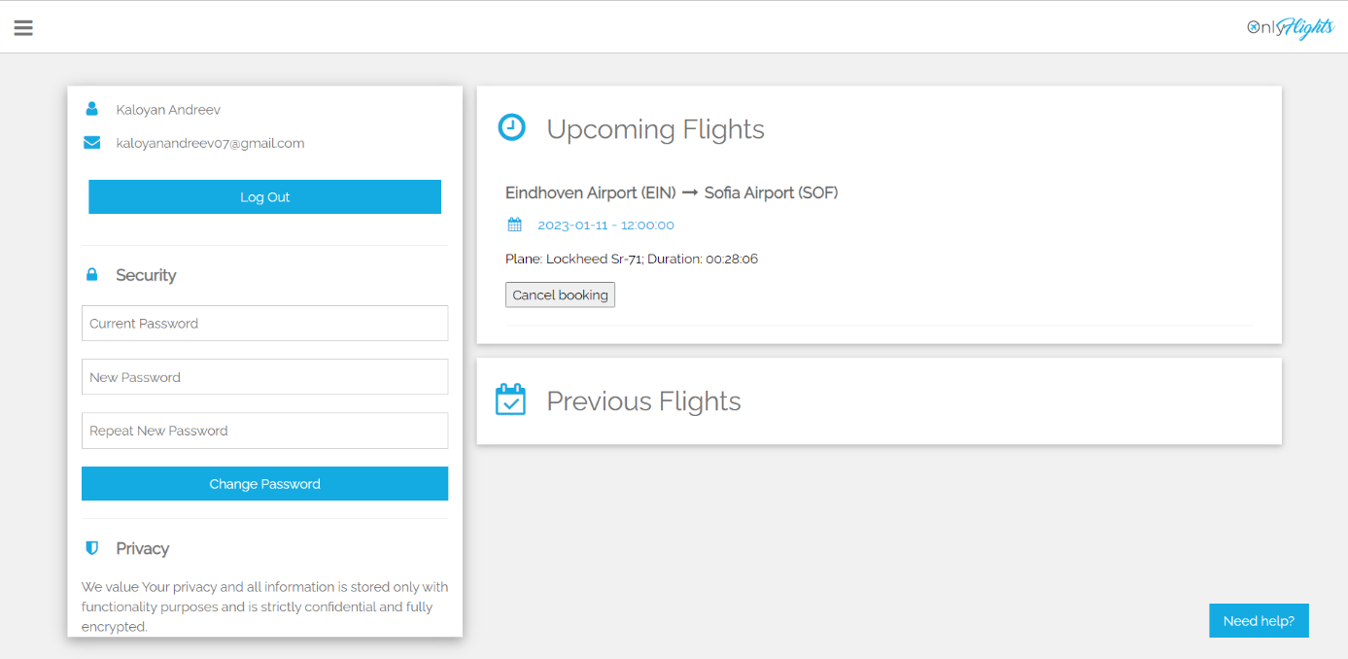

**1**

**2**

**3**

**4**

## Requirement before start using the website

* The only requirement the before start using the website is to make a registration

## Troubles while using the app ?

In case of technical failure please report it immediately to one of the following developers so it could be solved as soon as possible

**Contact info:**

* [k.andreev@student.fontys.com](mailto:k.andreev@student.fontys.com)
* [sava.vasilev@student.fontys.com](mailto:sava.vasilev@student.fontys.com)
* [f.marco@student.fontys.nl](mailto:f.marco@student.fontys.nl)